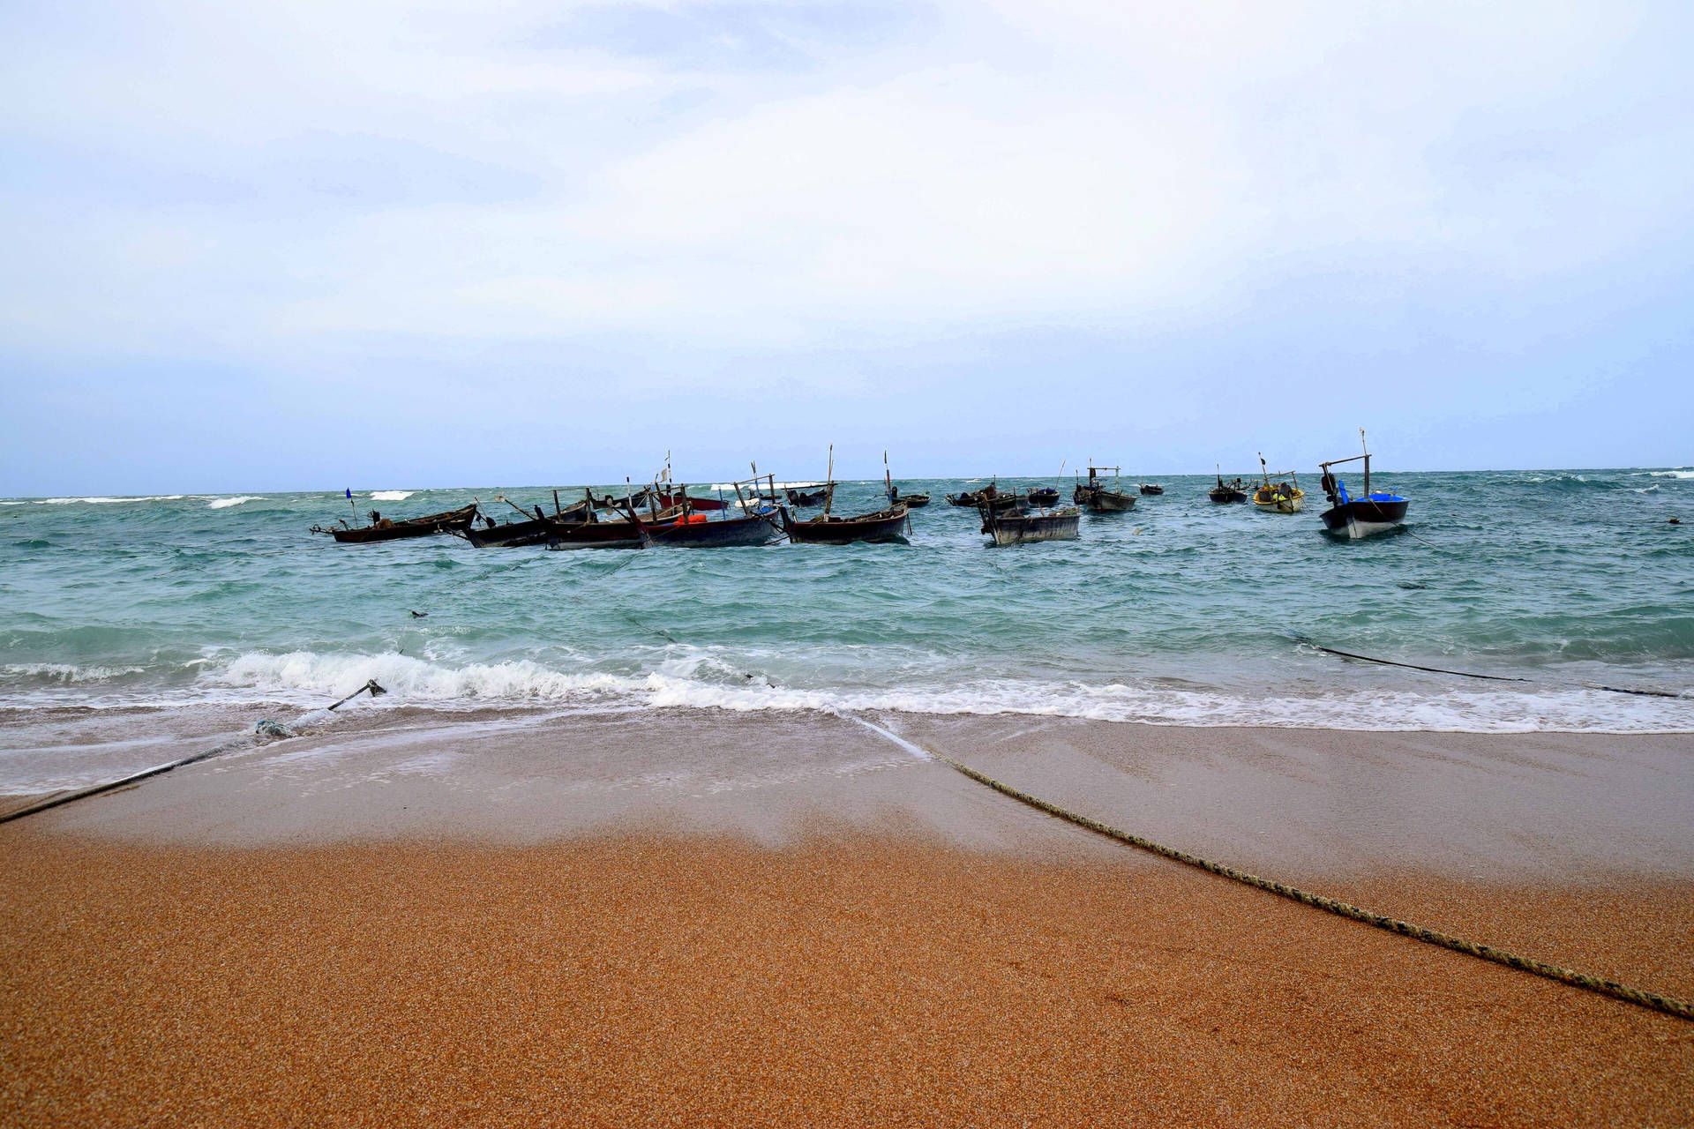

**MUBARAK VILLAGE**

**Discover the Untouched Charm of Mubarak Beach**

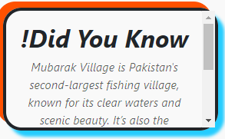Nestled along the coastline of Karachi, Mubarak Beach is a hidden gem that boasts pristine beauty and a serene atmosphere. Far away from the city's bustling crowds, the beach offers a tranquil escape where you can relax and unwind in nature's lap. Known for its crystal-clear waters, golden sands, and unspoiled landscapes, Mubarak Beach provides the perfect setting for those seeking a peaceful retreat. Whether you’re taking a leisurely stroll along the shore, soaking up the sun, or simply enjoying the gentle sound of the waves, this beach offers a rejuvenating experience like no other. Its untouched charm makes it a must-visit destination for nature lovers and explorers alike.

**A Paradise for Adventure Enthusiasts at Mubarak Beach**

Mubarak Beach isn’t just about relaxation; it’s also a haven

for thrill-seekers and adventure enthusiasts. The turquoise

waters of the Arabian Sea surrounding the beach are ideal for a variety of water activities, including snorkeling, scuba diving, and jet skiing. For those who love fishing, Mubarak Beach offers an exciting opportunity to catch a variety of marine life. Adventurous souls can also explore the nearby rock formations and cliffs, offering panoramic views of the vast sea. The combination of thrilling activities and breathtaking natural beauty ensures that Mubarak Beach offers something special for every visitor, making it a top destination for unforgettable experiences.

**Mubarak Beach: Where Nature Meets Serenity**

If you're searching for a place to connect with nature, Mubarak Beach offers a perfect blend of serenity and scenic beauty. The beach is surrounded by dramatic rocky landscapes and untouched coastlines, creating a picturesque environment that feels like stepping into a postcard. Visitors can enjoy a peaceful day surrounded by the calming sights and sounds of nature, away from the stress of daily life. Mubarak Beach is not just a spot for relaxation but also a unique location to witness the rich biodiversity of the area. From spotting seabirds to observing marine life in the clear waters, the beach provides a truly immersive natural experience.

**Why Mubarak Beach is a Must-Visit Destination**

Mubarak Beach is more than just a beach; it’s an experience that captures the essence of Karachi’s coastal beauty. Whether you’re looking to spend quality time with family, go on an adventurous outing with friends, or enjoy a solo retreat, Mubarak Beach offers the perfect setting for every occasion. The beach's clean and peaceful environment, combined with the captivating views of the Arabian Sea, makes it an ideal spot for picnics, photography, or simply soaking in the beauty of nature. Mubarak Beach is not yet as commercialized as other beaches, preserving its authentic charm and making every visit feel like a unique getaway. It’s a destination that promises lasting memories for all who visit.

***RIDING***

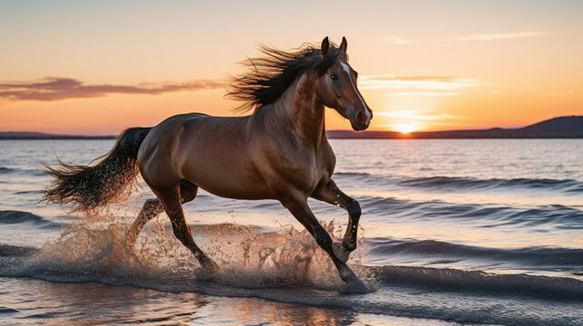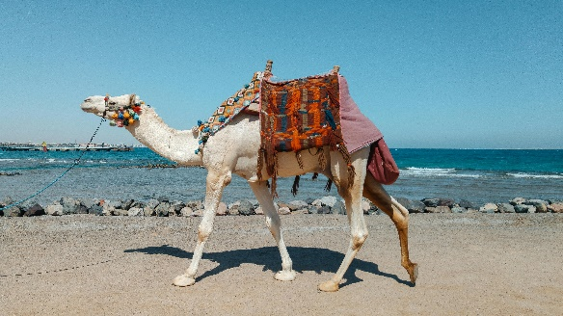

***! Camel riding at MUBARAK VILLAGE is a fun and iconic activity for visitors. Decorated camels offer safe rides guided by skilled handlers.***

***! Beach bike riding at MUBARAK VILLAGE offers a thrilling experience, with rental bikes designed for smooth rides on the sandy shoreline.***

***! Horse riding at MUBARAK VILLAGE is another thrilling activity for visitors. Beautifully adorned horses are available for guided rides along the shoreline.***

**Explore the Rustic Beauty of Mubarak Village**

Mubarak Village, located along the western coastline of Karachi, is a serene fishing village that offers an authentic glimpse into the simple coastal lifestyle of Pakistan. Surrounded by rugged mountains, turquoise waters, and golden sandy shores, this picturesque village is a hidden gem for nature enthusiasts and adventure seekers. Known for its untouched landscapes and warm hospitality, Mubarak Village provides a peaceful escape from the fast-paced urban life. Visitors can stroll through the village to witness the vibrant culture and traditional fishing practices of the locals, making it a unique destination that combines natural beauty with cultural charm. From enjoying breathtaking sunset views to embarking on boat rides to nearby islands, Mubarak Village is a place that captivates the hearts of all who visit.

**Mubarak Village: A Gateway to Coastal Adventure**

Mubarak Village isn’t just a scenic destination; it’s also a hub for thrilling adventures and exploration. The pristine waters surrounding the village are perfect for activities such as snorkeling, scuba diving, and fishing, offering a chance to experience the rich marine life of the Arabian Sea up close. The village is also the starting point for boat trips to Charna Island, a popular spot for water sports and underwater exploration. The rugged hills around Mubarak Village invite hikers to explore the breathtaking landscapes, while photographers can capture stunning panoramic views of the coast. With its untouched beauty and endless opportunities for adventure, Mubarak Village is a must-visit destination for anyone looking to connect with nature and explore Pakistan's coastal treasures.

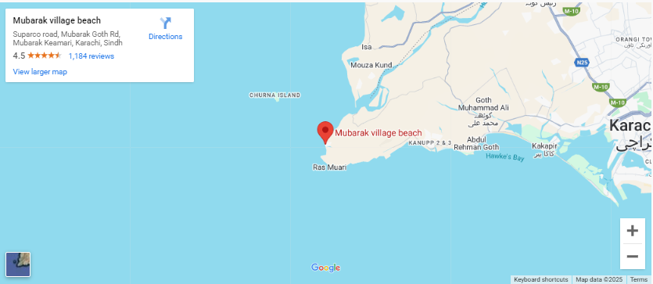**LOCATION**

Mubarak Village is located near the coast, east of Karachi, in the Sindh-Balochistan border area. It's a fishing village, situated along the Arabian Sea, close to the Mubarak Village Beach.

**Why Visit Mubarak Village?**

**Mubarak Village offers stunning turquoise waters, golden sands, and a peaceful escape. From exploring local culture to enjoying snorkeling and boat rides, it’s a perfect mix of relaxation and adventure.**

**FEATURED PRODUCT**









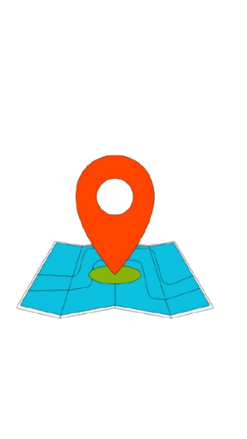**SHOP LOCATION**

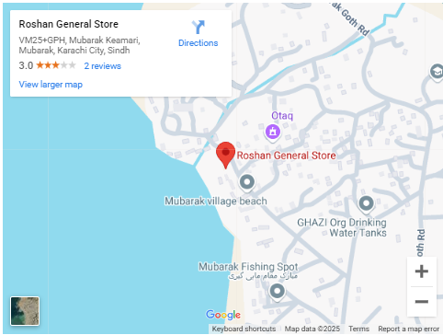

There are several general stores with the name "Roshan General Store" in Karachi and other areas of Pakistan. Without a specific area or neighborhood, it's hard to pinpoint the exact location